Cairo University Faculty of Computers and Artificial Intelligence



**Software Design and Architecture**

**Software design specification document**

**2021**

**Project Team**

|  |  |  |  |
| --- | --- | --- | --- |
| **ID** | **Name** | **Email** | **Mobile** |
| 20196028 | Sherif emad taha mahmoud | Sherif.emad1091@gmail.com |  |
| 20196062 | Youssef elsayed Mahmoud | Youssef.elsayed2001@gmail.com |  |
| 20196047 | Muhammed essam eldin | Muhammedessamq@icloud.com |  |
|  |  |  |  |
|  |  |  |  |
|  |  |  |  |

**[TA MuhammedSamir]**

Contents

Class diagram design 2

Sequence diagram design 3

Github repository link 5

# Class diagram design

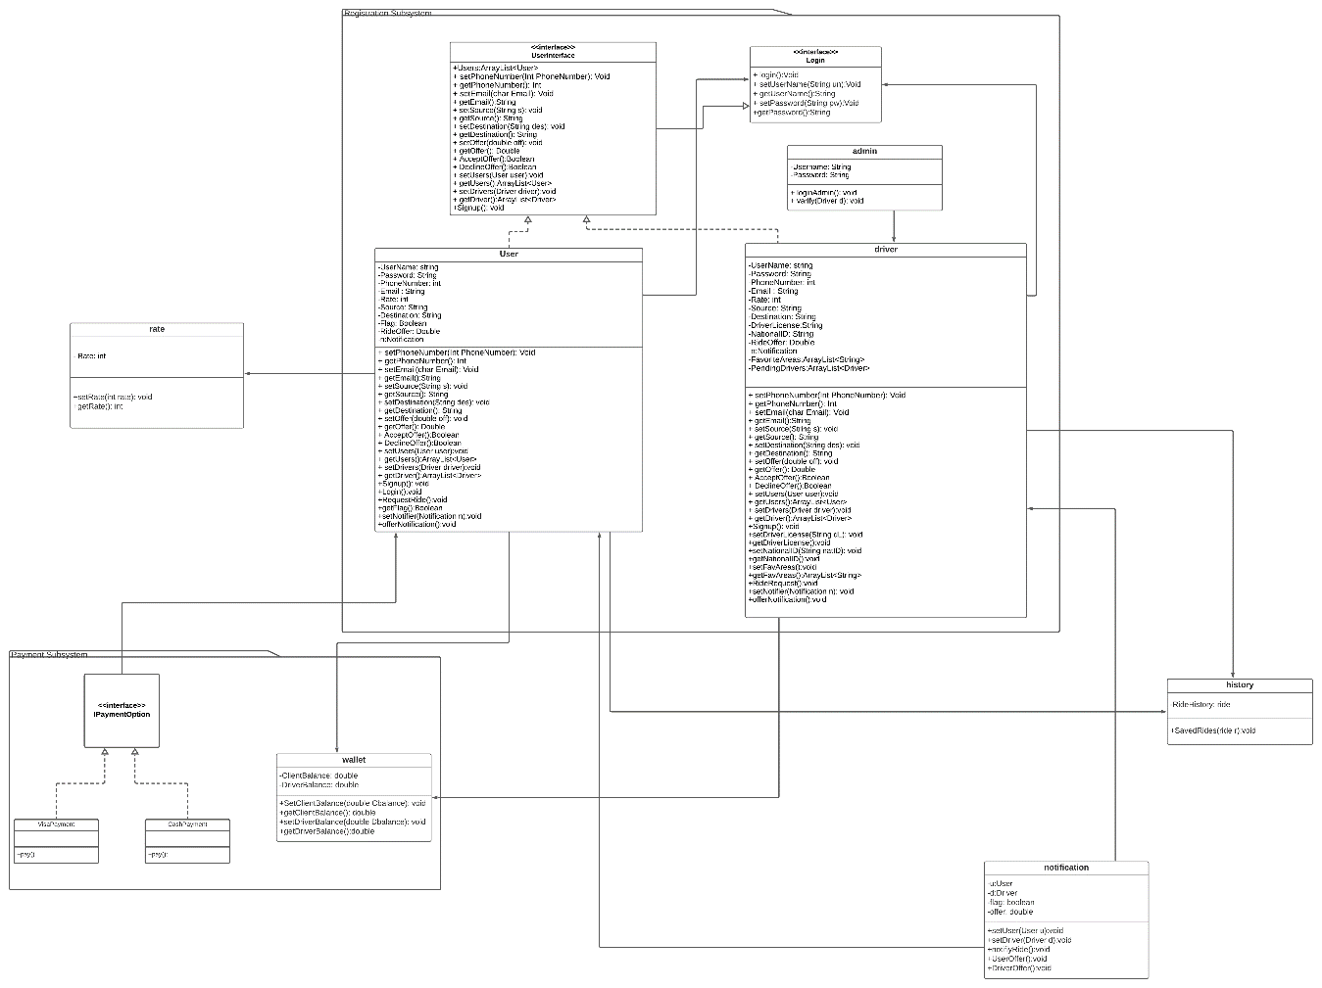

# Sequence diagram design

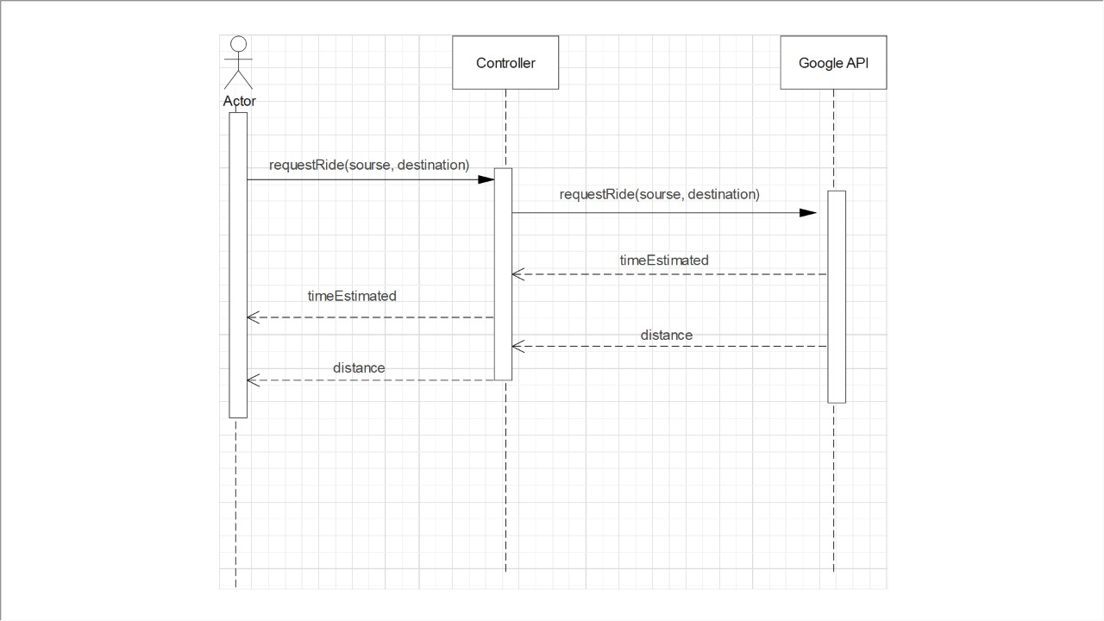

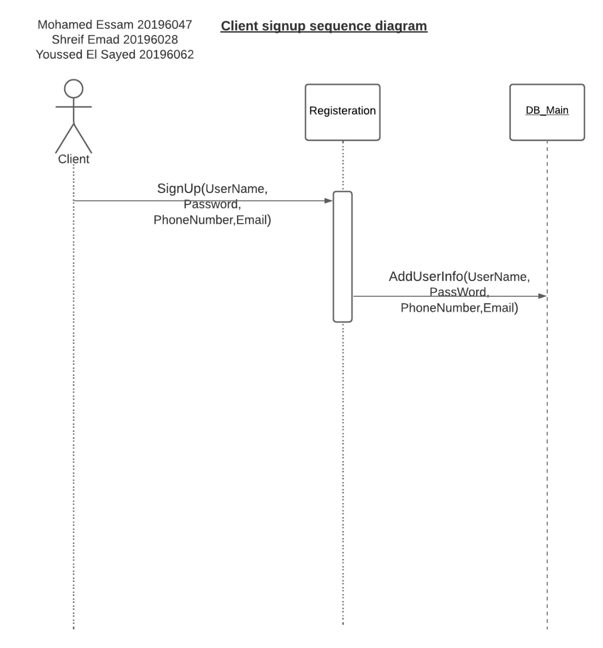

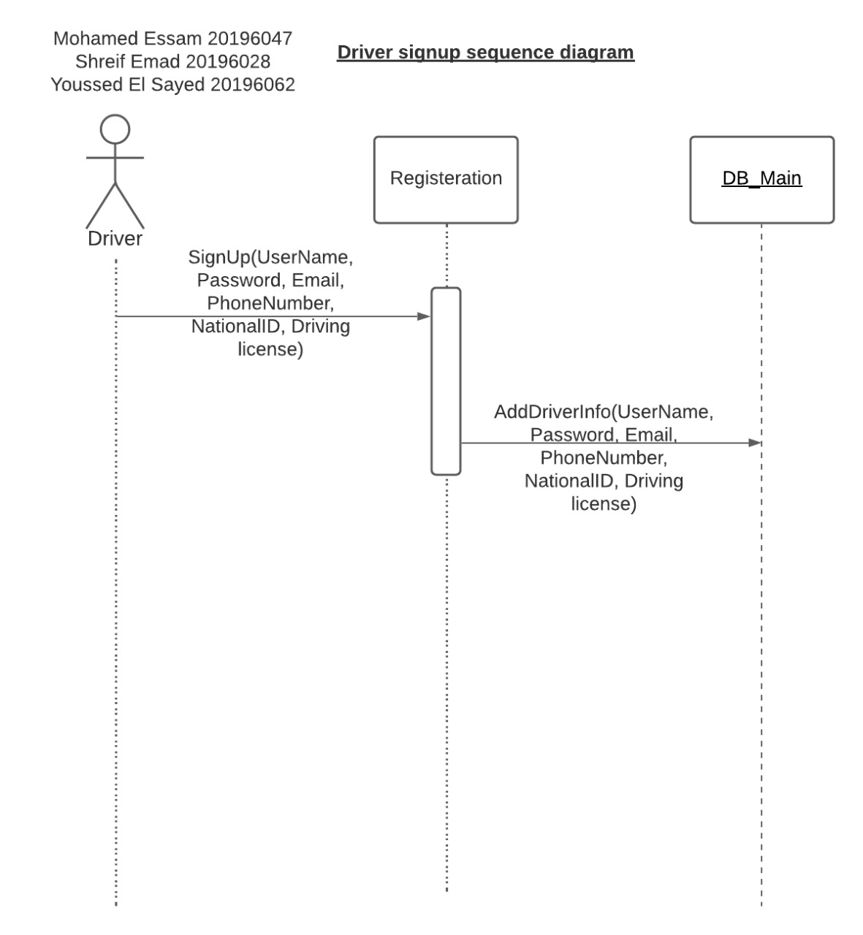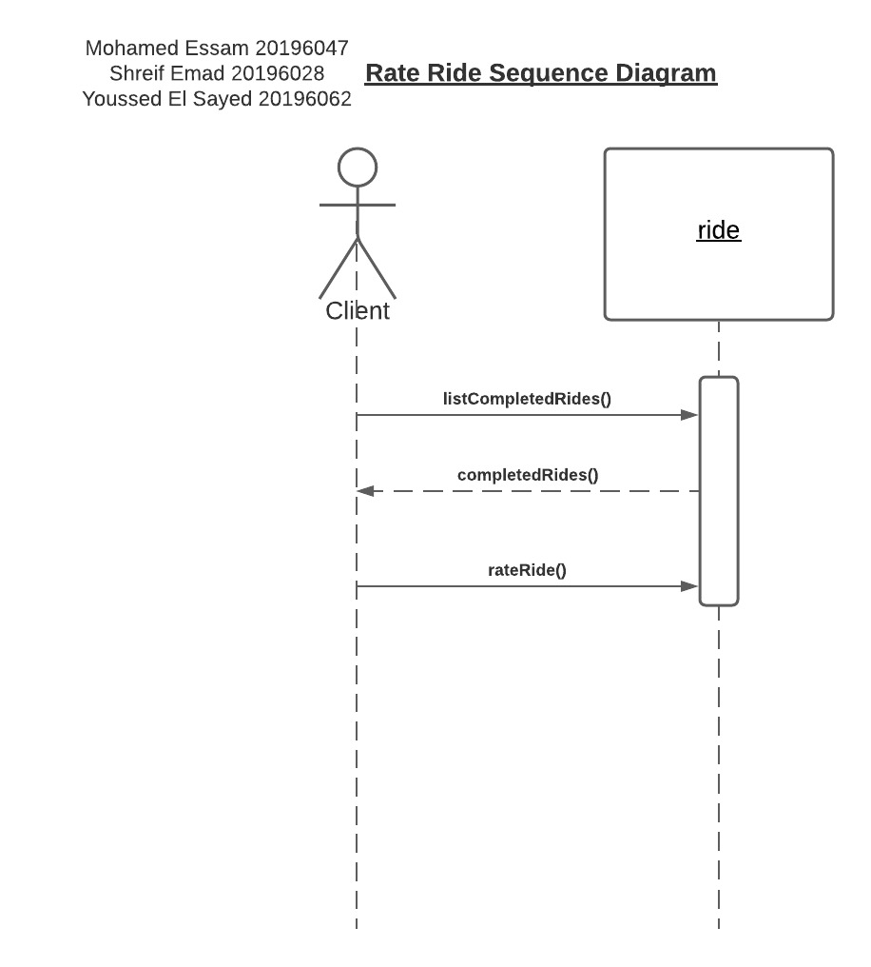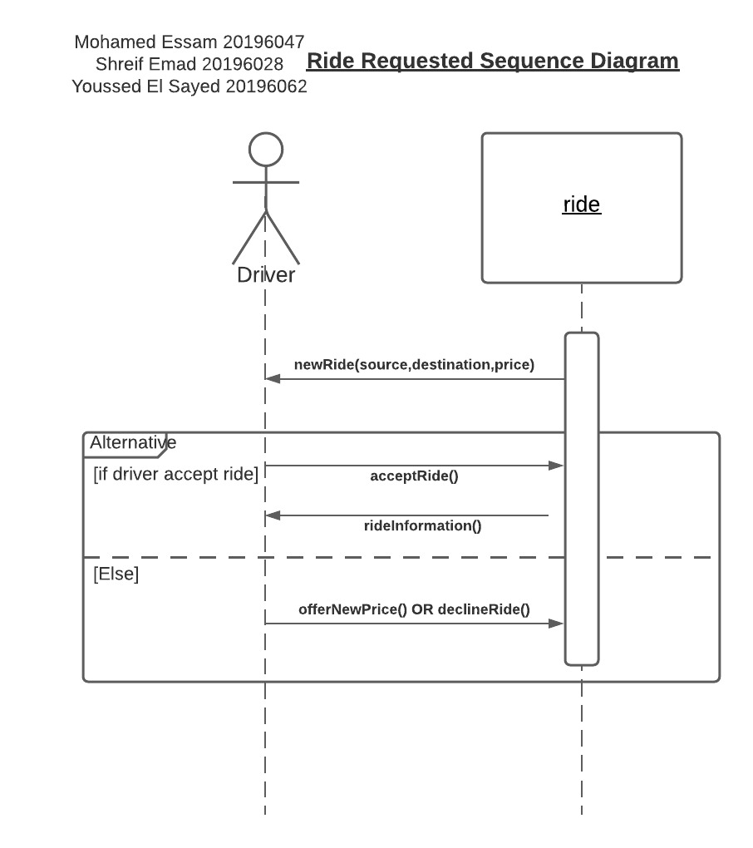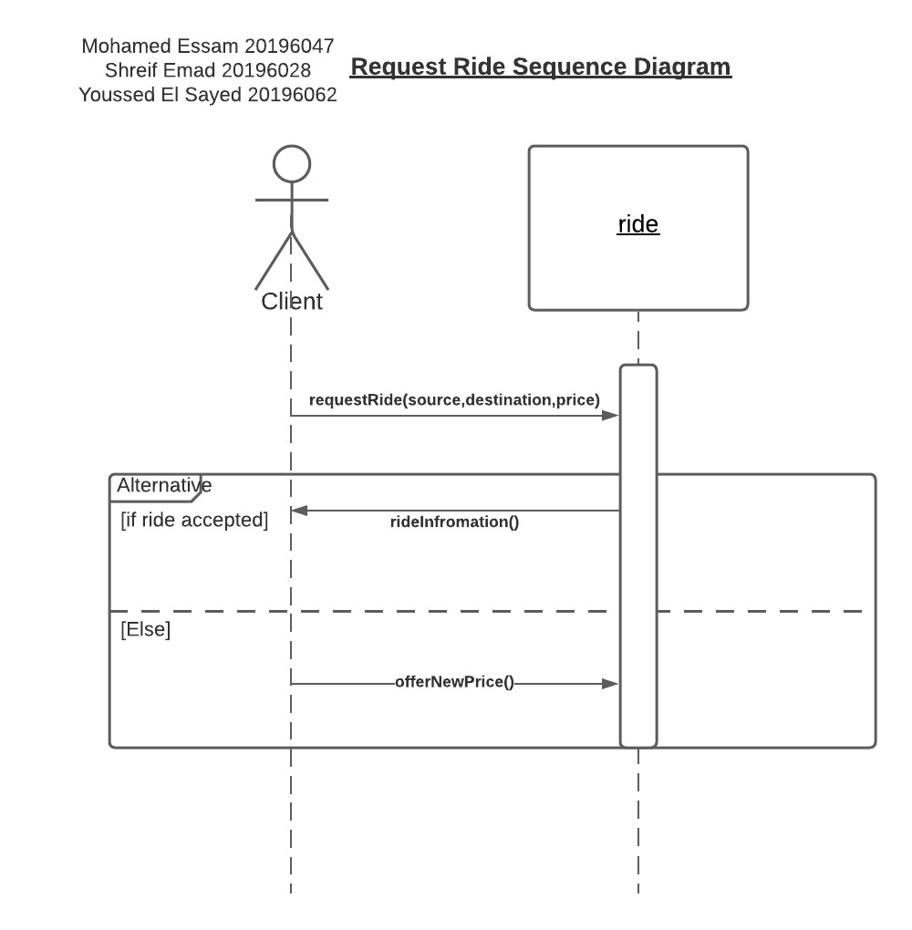

# Github repository link

https://github.com/youssefelsayednada/Sw-architecture.git